Lawson Dietz

CS450 F22

Final Project

<https://media.oregonstate.edu/media/t/1_3qmtqzfl>

(I have included the entire solution in case just the .cpp and images do not run for some reason)

My final project is a scene from a map from the game VALORANT. The map’s name is called Fracture and the name of the scene is called A site and it is a location on the map Fracture. The scene is fully textured and you can look at different views throughout the scene using 0 – 4 on the numpad.

My project differs from my original because I was unable to get lighting to work properly on the textures that I was using. Some special things that I did that were clever were to use a loop to make both of the stairs and texture them. I was also able to cleverly adjust the s and t coordinates to correctly align the textures. Some things that I did not know before this project were manually entering texture coordinates through s and t and how to get my own images from .bmp to appearing in the scene.

PICTURES FROM VALORANT

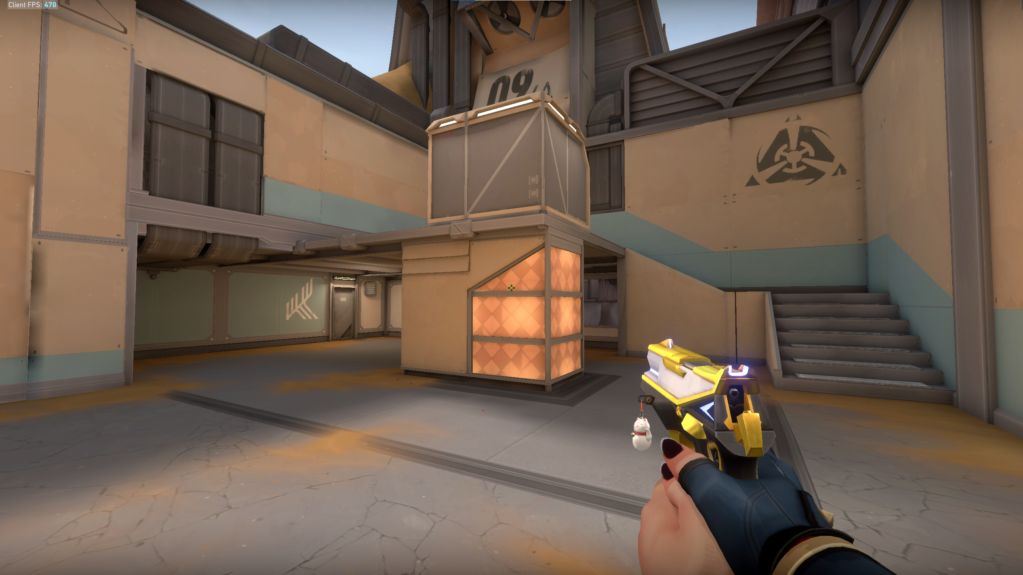

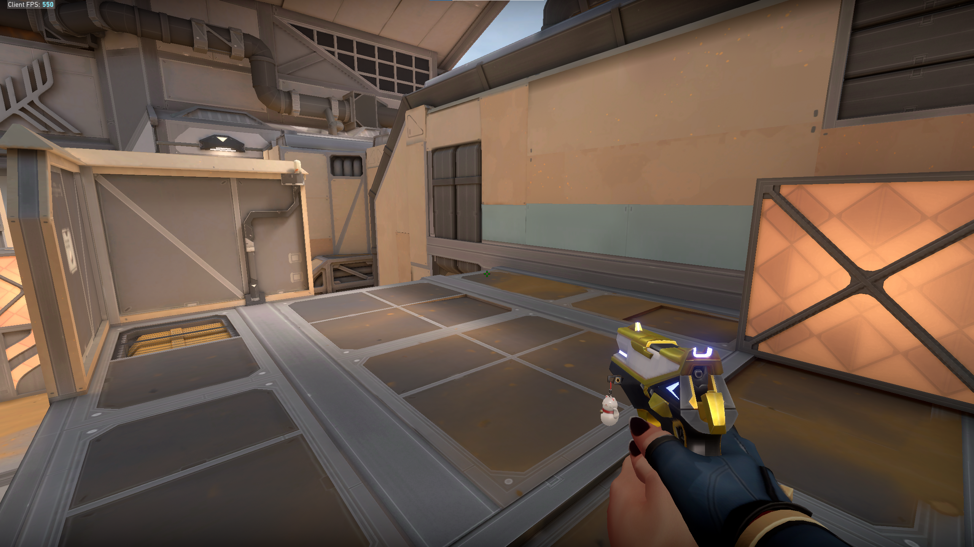

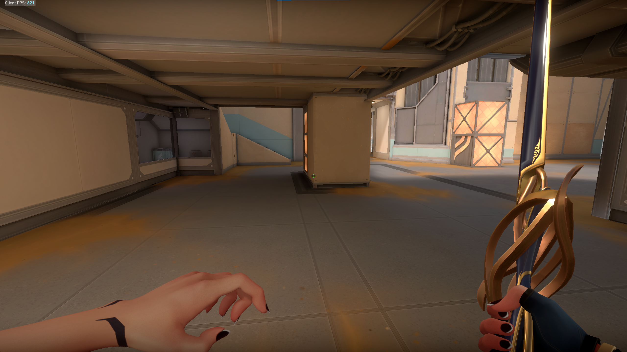

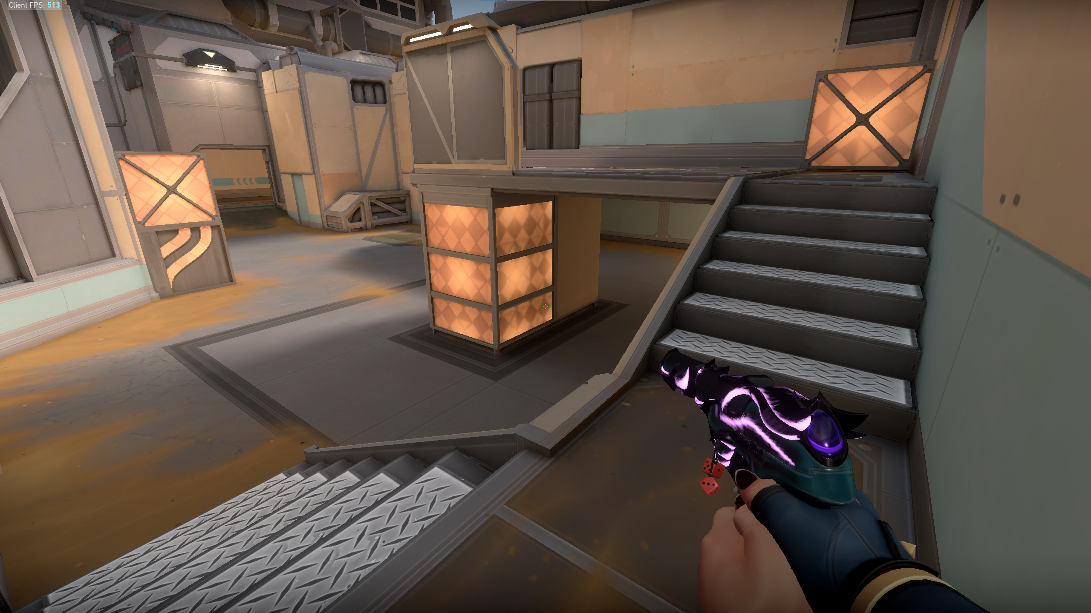

PICTURES FROM MY SCENE

